RoadMap:

Current Flow:

Link: [https://node-red-nvdyw-2021-06-16-optum.eu-gb.mybluemix.net/welcome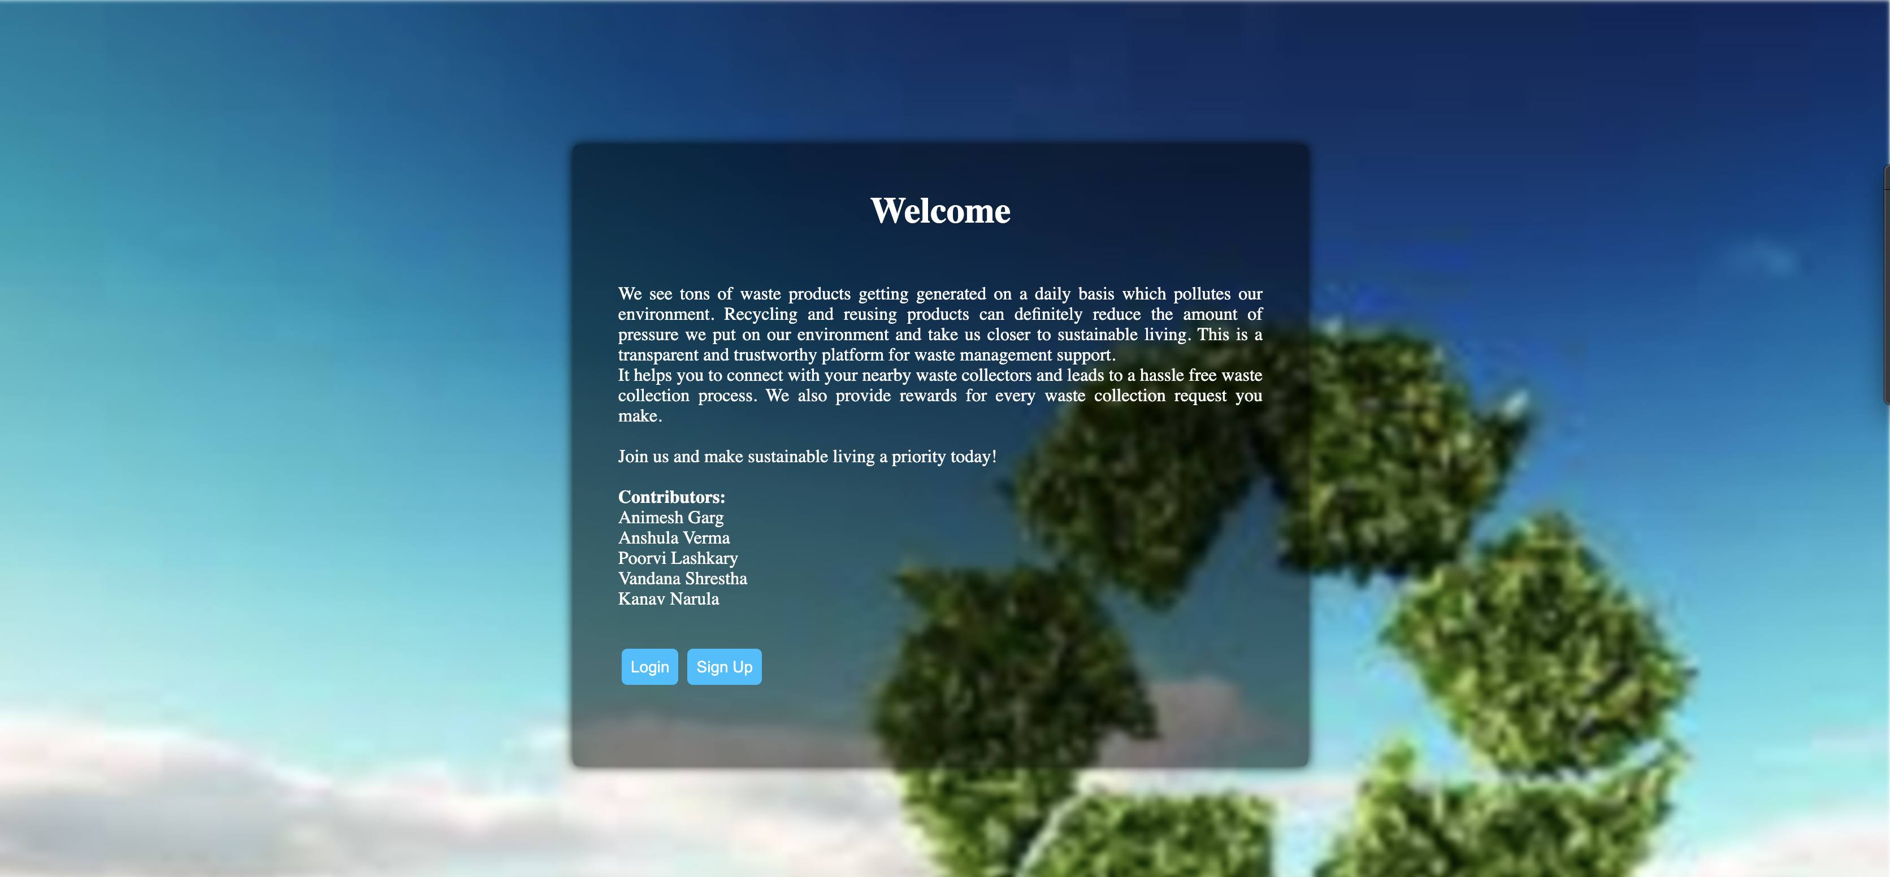](https://node-red-nvdyw-2021-06-16-optum.eu-gb.mybluemix.net/welcome#)

Login Page:

Link: [https://node-red-nvdyw-2021-06-16-optum.eu-gb.mybluemix.net/wclogin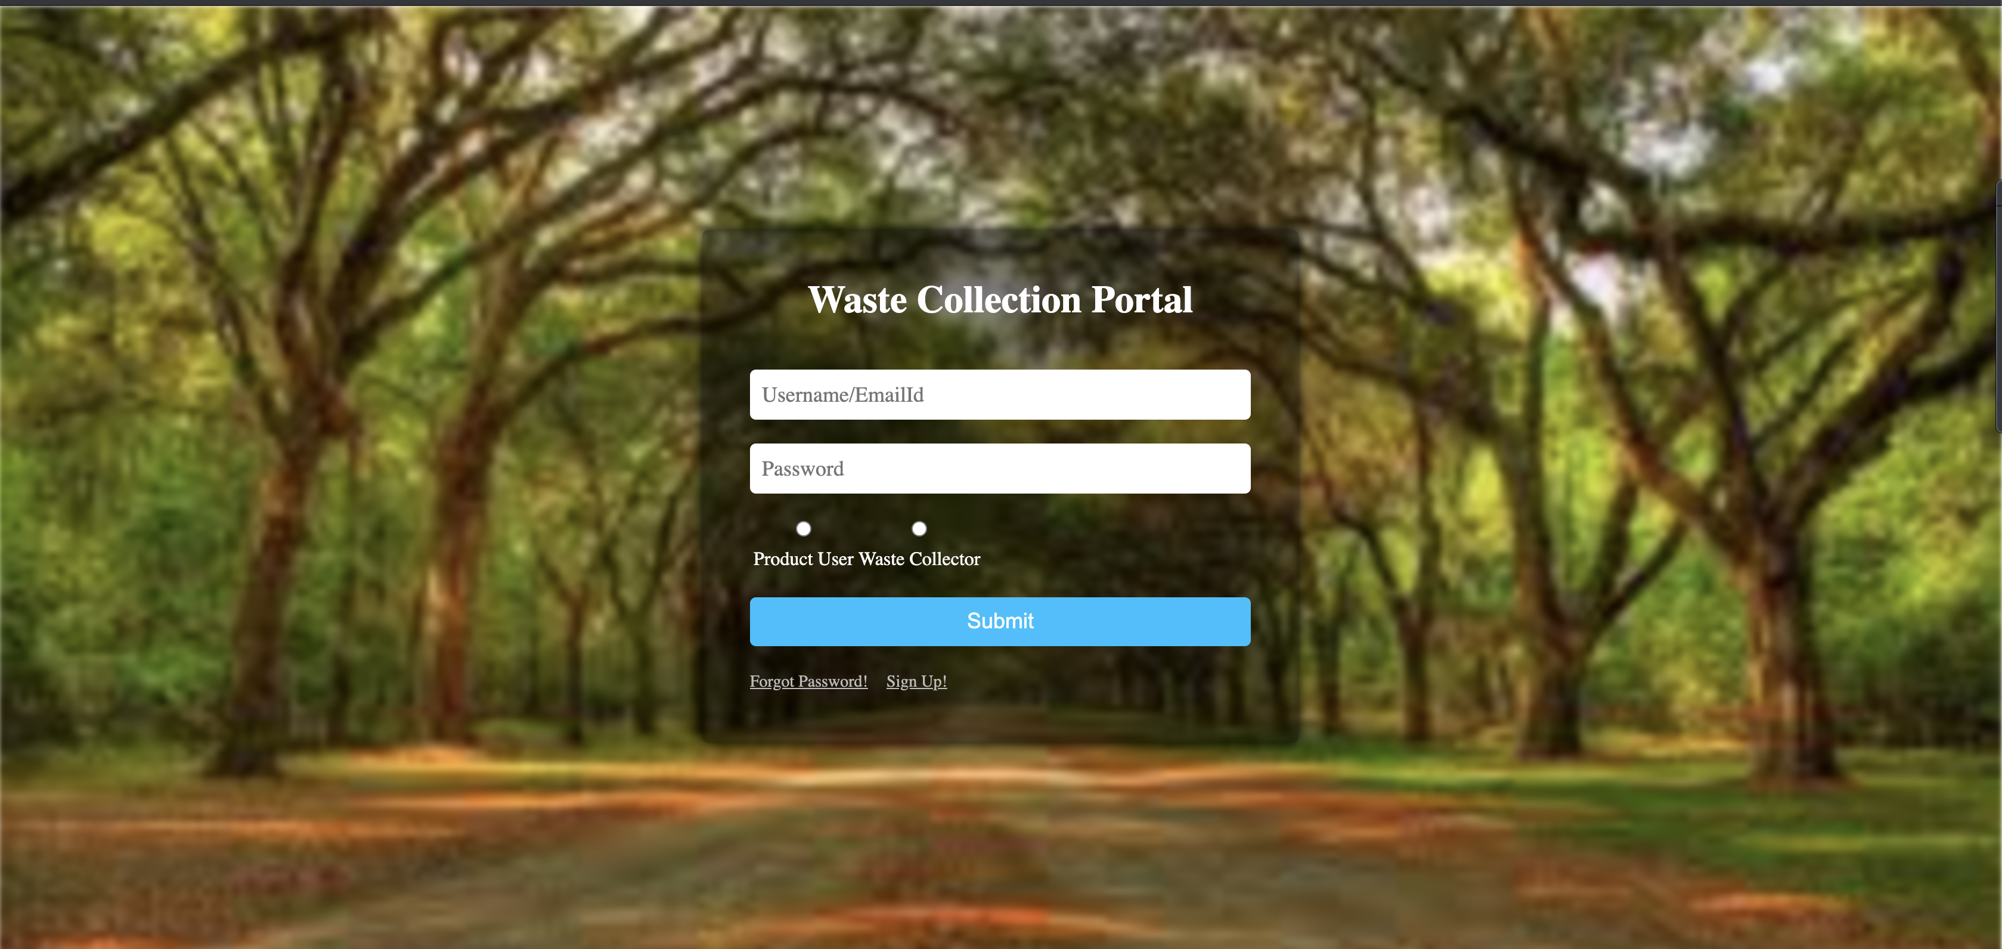](https://node-red-nvdyw-2021-06-16-optum.eu-gb.mybluemix.net/wclogin#)

Sign Up:

Link: <https://node-red-nvdyw-2021-06-16-optum.eu-gb.mybluemix.net/sign>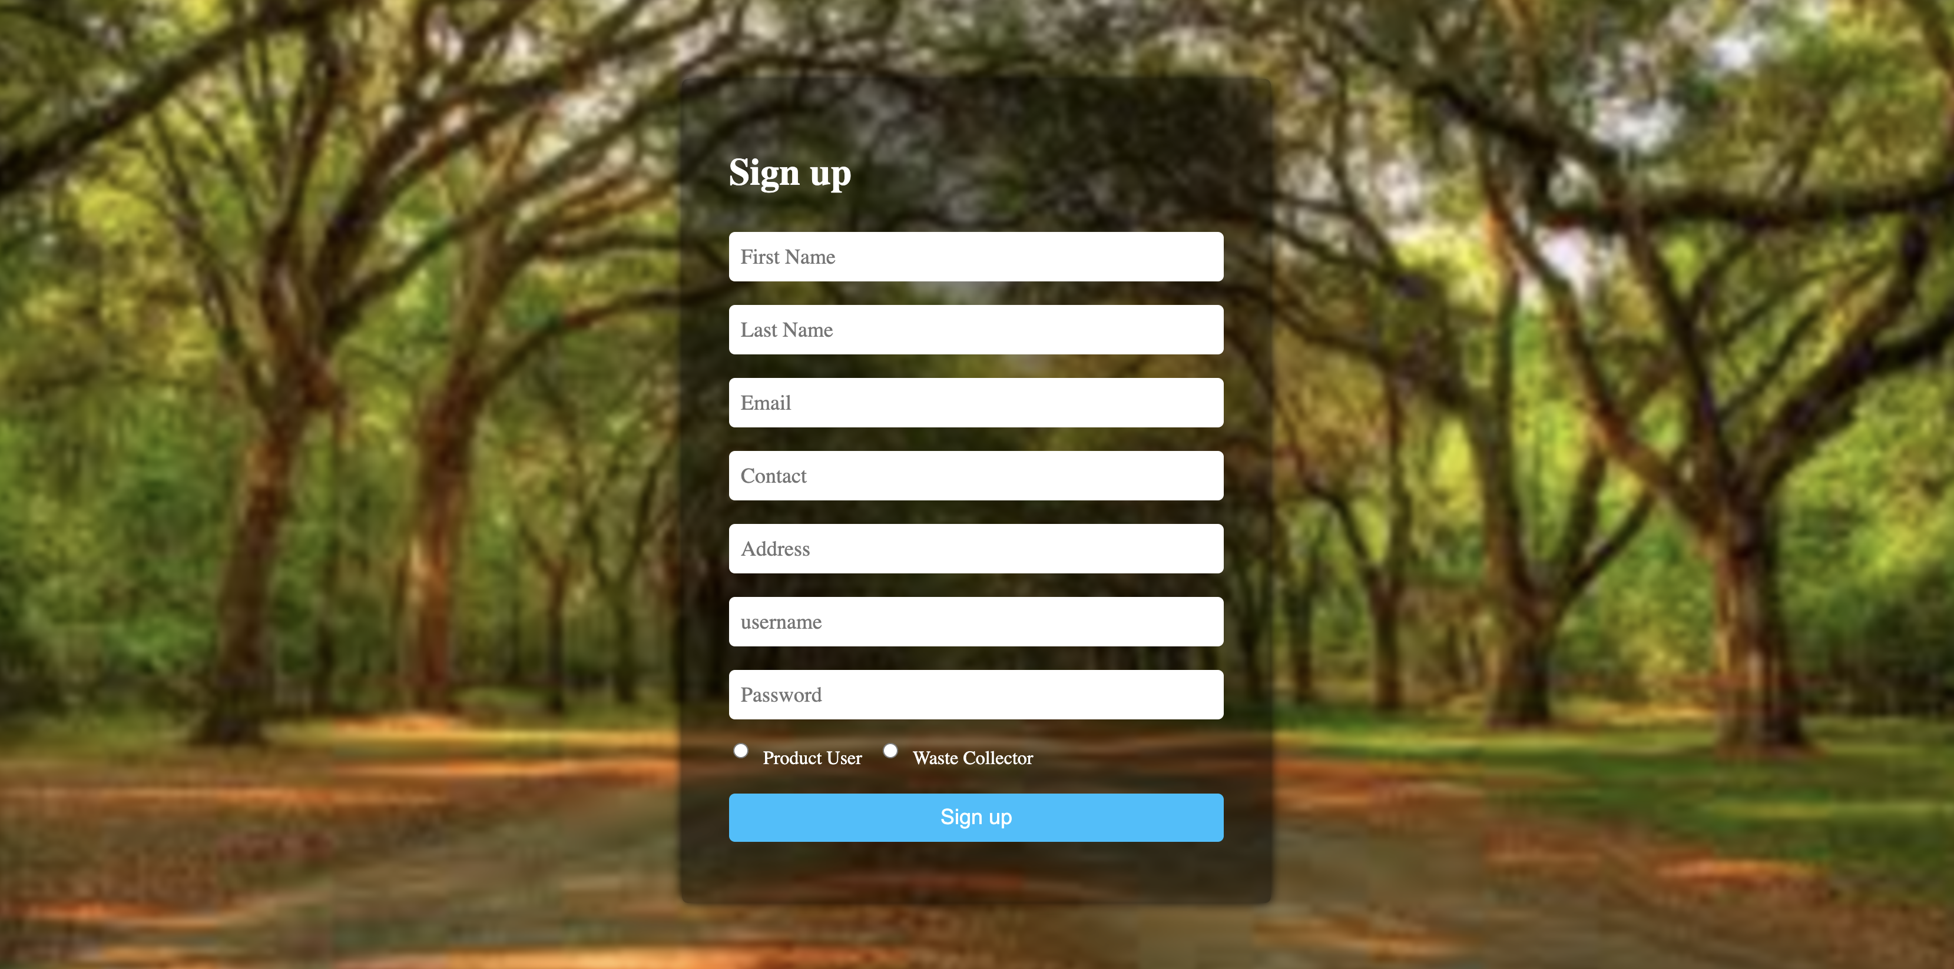

User Main Portal:

Link: [https://node-red-nvdyw-2021-06-16-optum.eu-gb.mybluemix.net/userdetails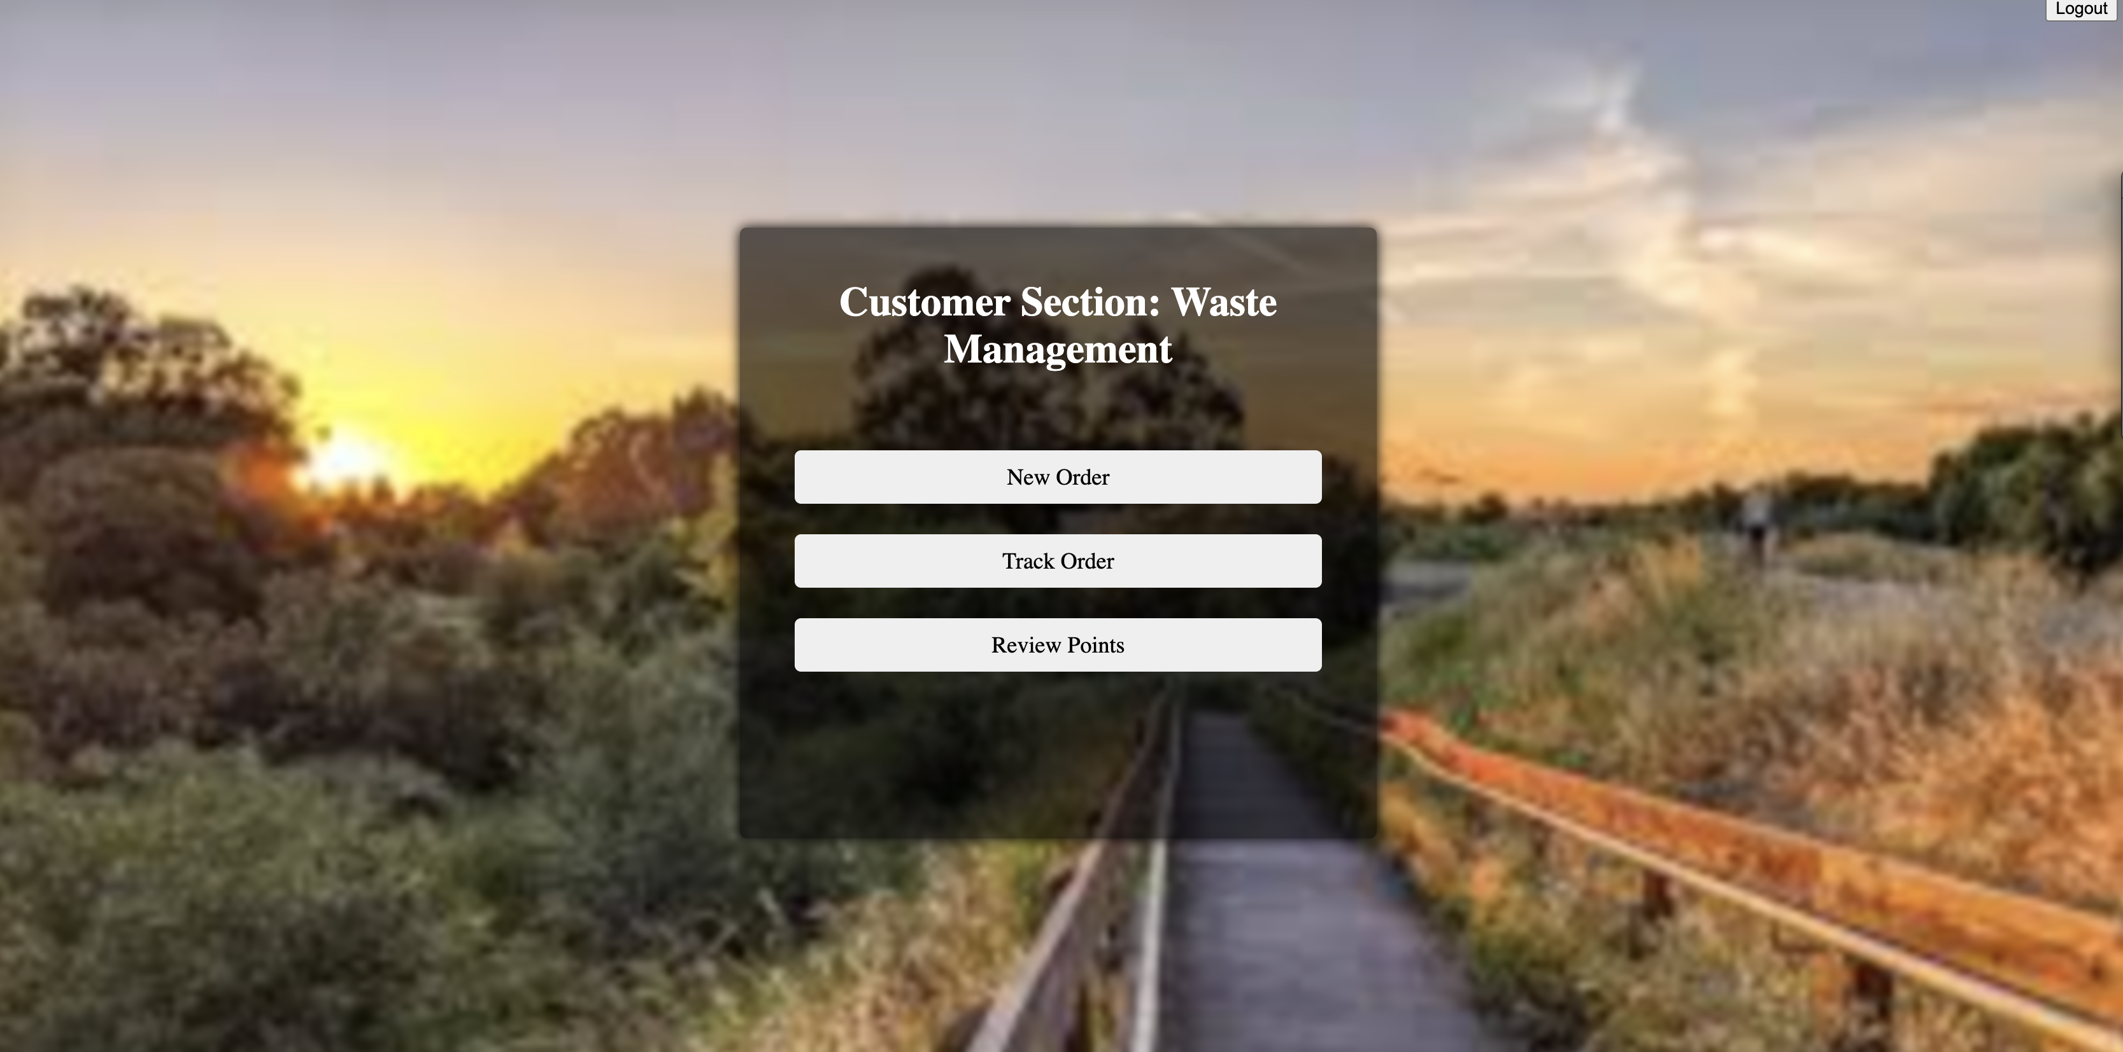](https://node-red-nvdyw-2021-06-16-optum.eu-gb.mybluemix.net/userdetails#)

User - New Order:

Link: <https://node-red-nvdyw-2021-06-16-optum.eu-gb.mybluemix.net/neworder>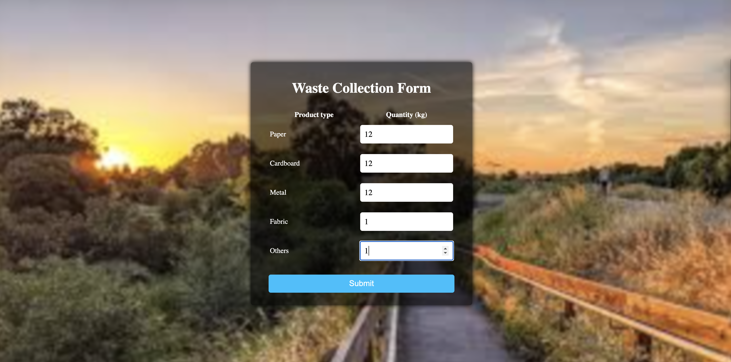

User - Track Order:

Link: [https://node-red-nvdyw-2021-06-16-optum.eu-gb.mybluemix.net/trackorder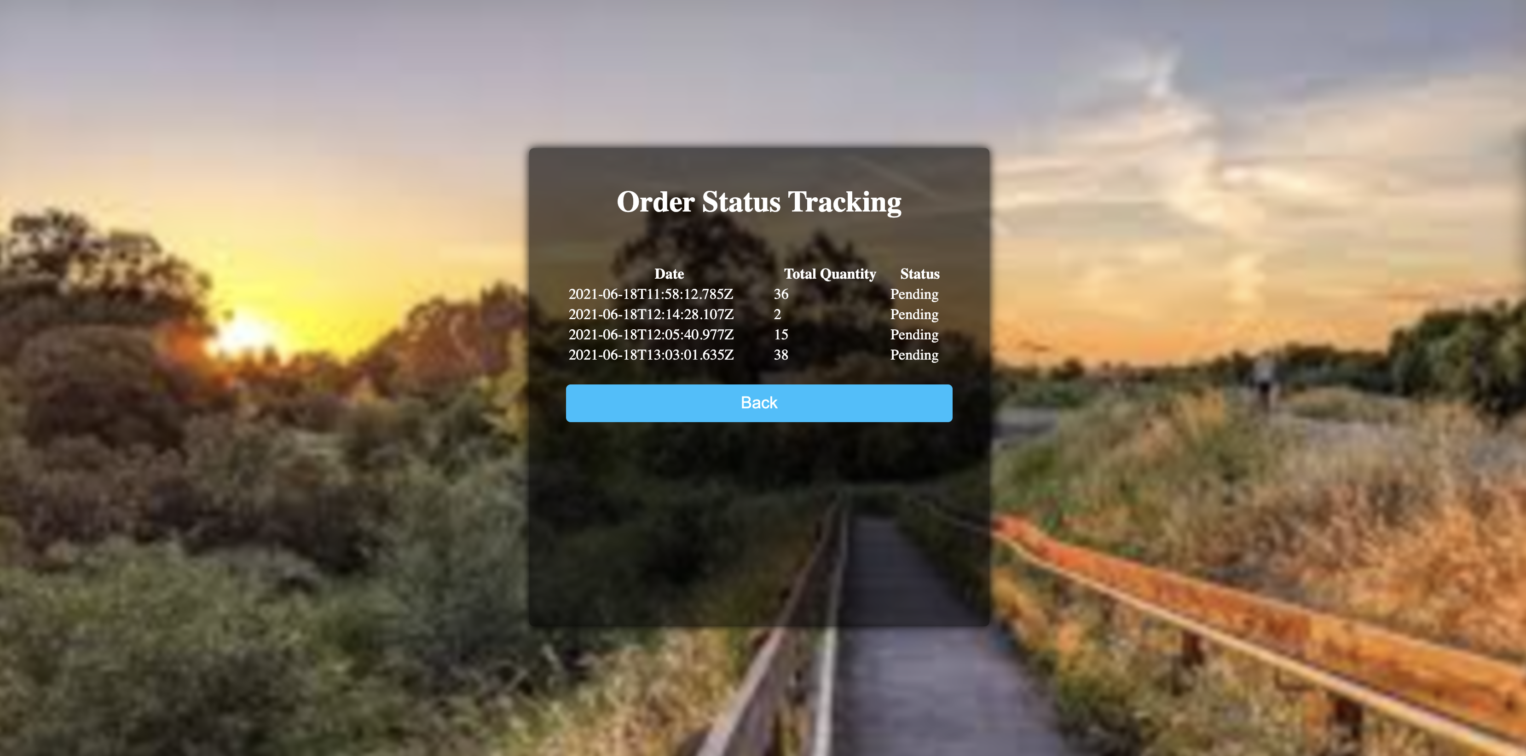](https://node-red-nvdyw-2021-06-16-optum.eu-gb.mybluemix.net/trackorder#)

User – Reward summary:

Link: <https://node-red-nvdyw-2021-06-16-optum.eu-gb.mybluemix.net/userrewards>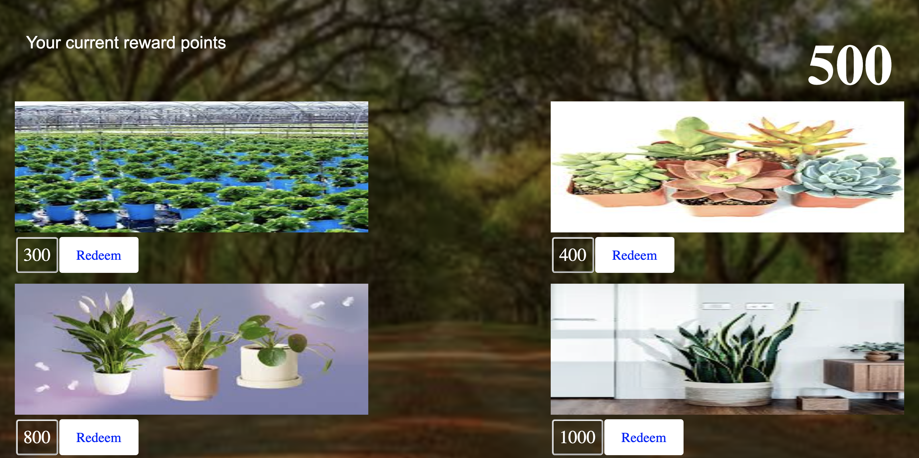

Waste Collector – Main Page:

Link: [https://node-red-nvdyw-2021-06-16-optum.eu-gb.mybluemix.net/wastecollectoroverview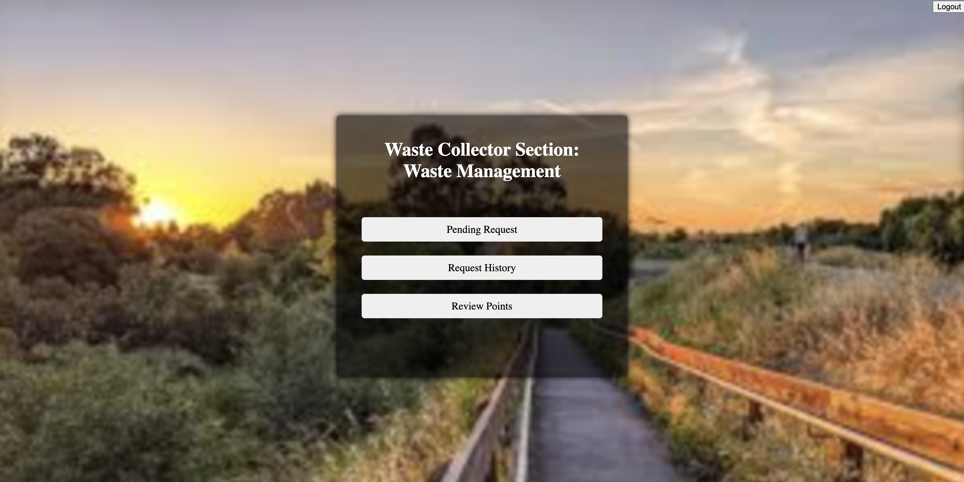](https://node-red-nvdyw-2021-06-16-optum.eu-gb.mybluemix.net/wastecollectoroverview#)

Waste Collector – Pending Request:

Link: [https://node-red-nvdyw-2021-06-16-optum.eu-gb.mybluemix.net/collectorpendingrequest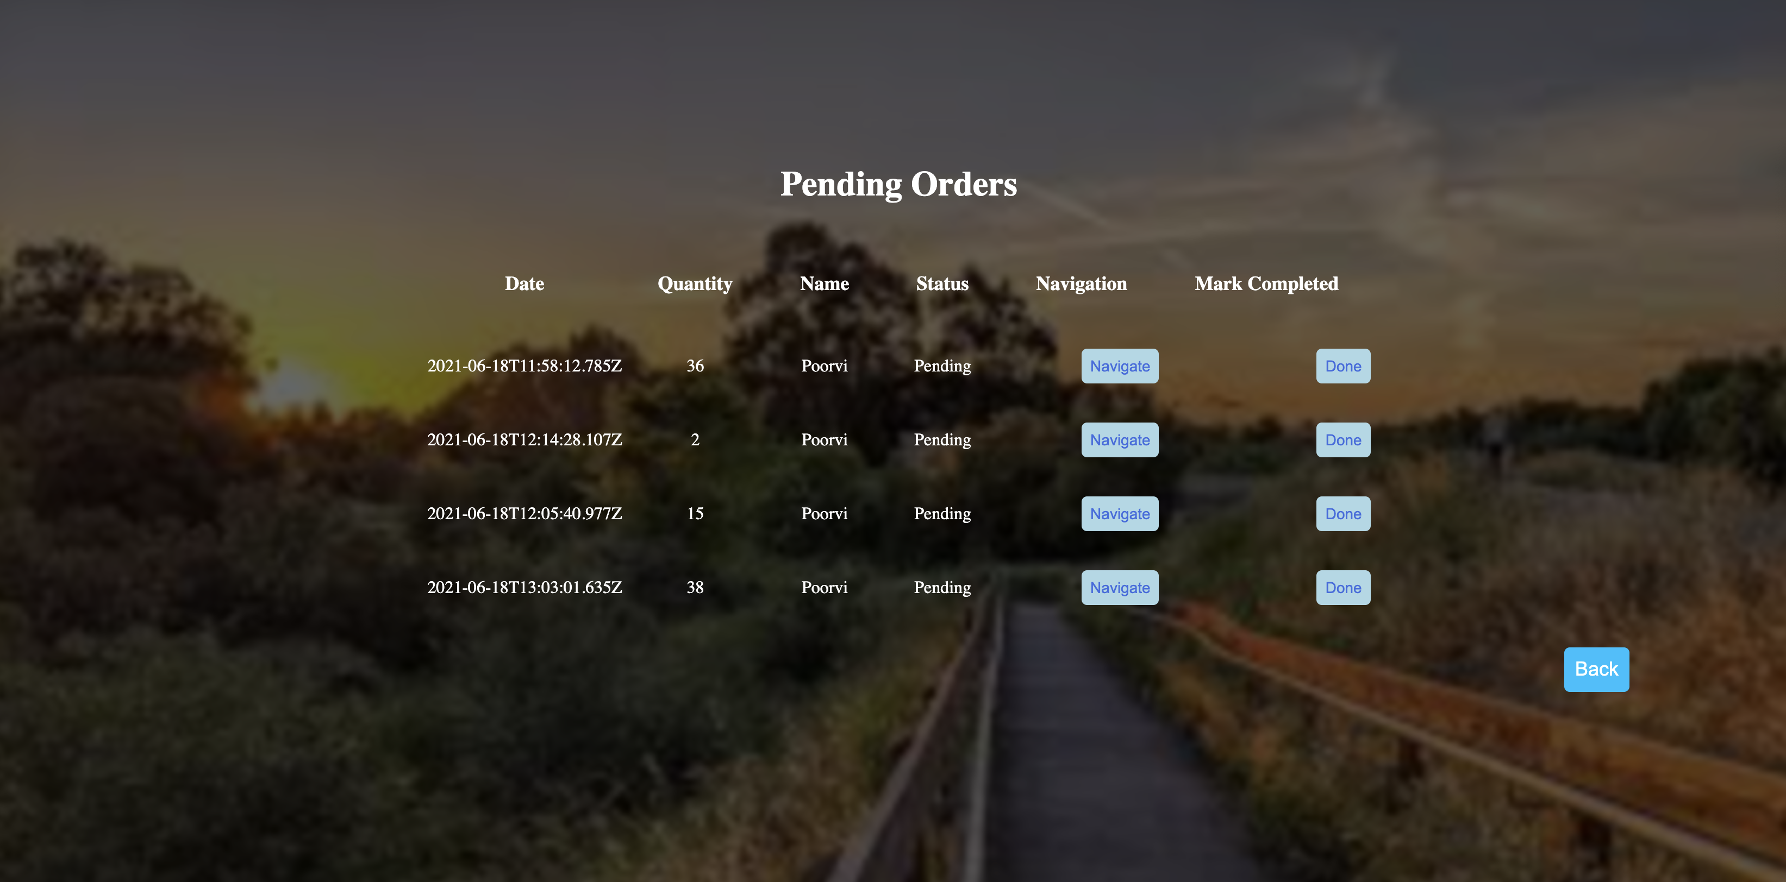](https://node-red-nvdyw-2021-06-16-optum.eu-gb.mybluemix.net/collectorpendingrequest#)

Waste Collector – Navigation:

Link: [https://node-red-nvdyw-2021-06-16-optum.eu-gb.mybluemix.net/ui/#!/0?socketid=L0kjBqBp_WvfbBozAADh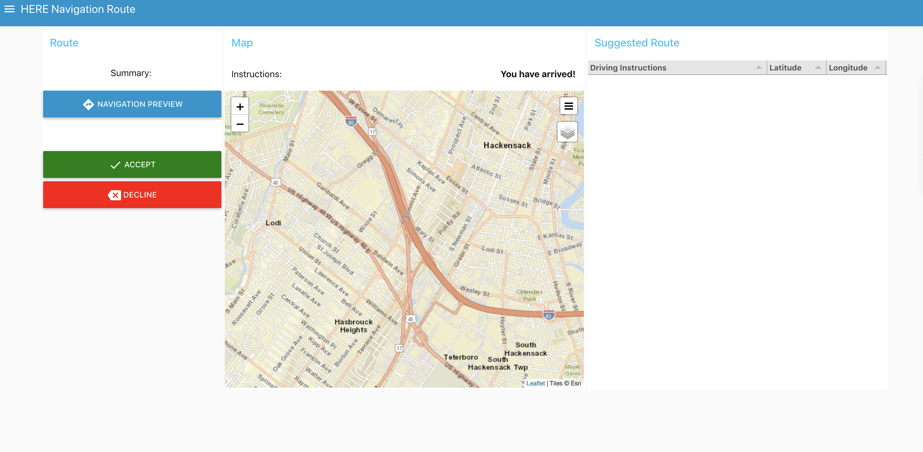](https://node-red-nvdyw-2021-06-16-optum.eu-gb.mybluemix.net/ui/#!/0?socketid=L0kjBqBp_WvfbBozAADh#)

Waste Collector – Request history:

Link: [https://node-red-nvdyw-2021-06-16-optum.eu-gb.mybluemix.net/collectorrequestrequest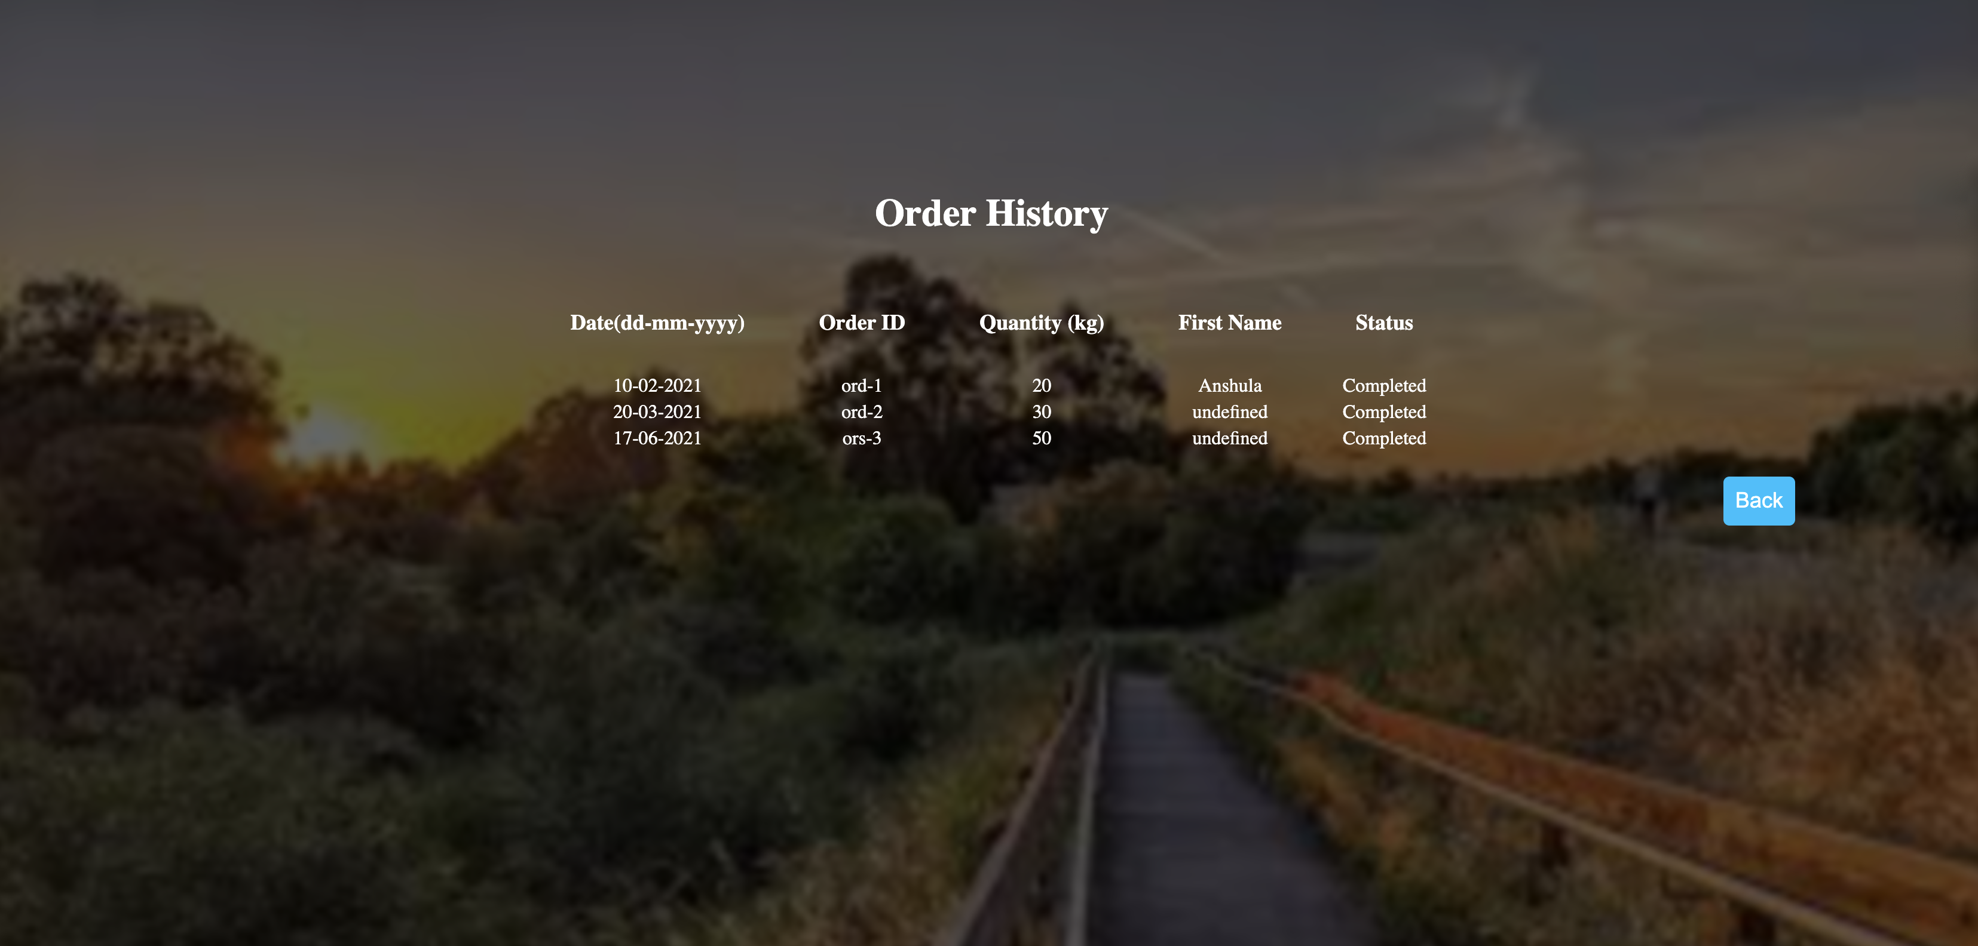](https://node-red-nvdyw-2021-06-16-optum.eu-gb.mybluemix.net/collectorrequestrequest#)

Waste Collector – Rewards summary:

Link: [https://node-red-nvdyw-2021-06-16-optum.eu-gb.mybluemix.net/rewards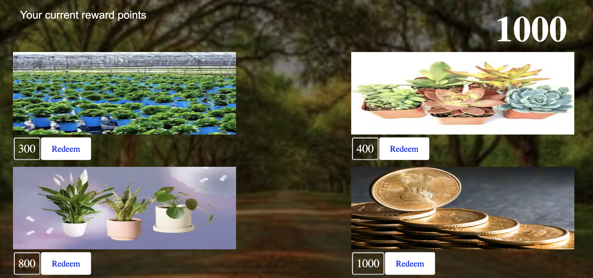](https://node-red-nvdyw-2021-06-16-optum.eu-gb.mybluemix.net/rewards#)

Database tables:

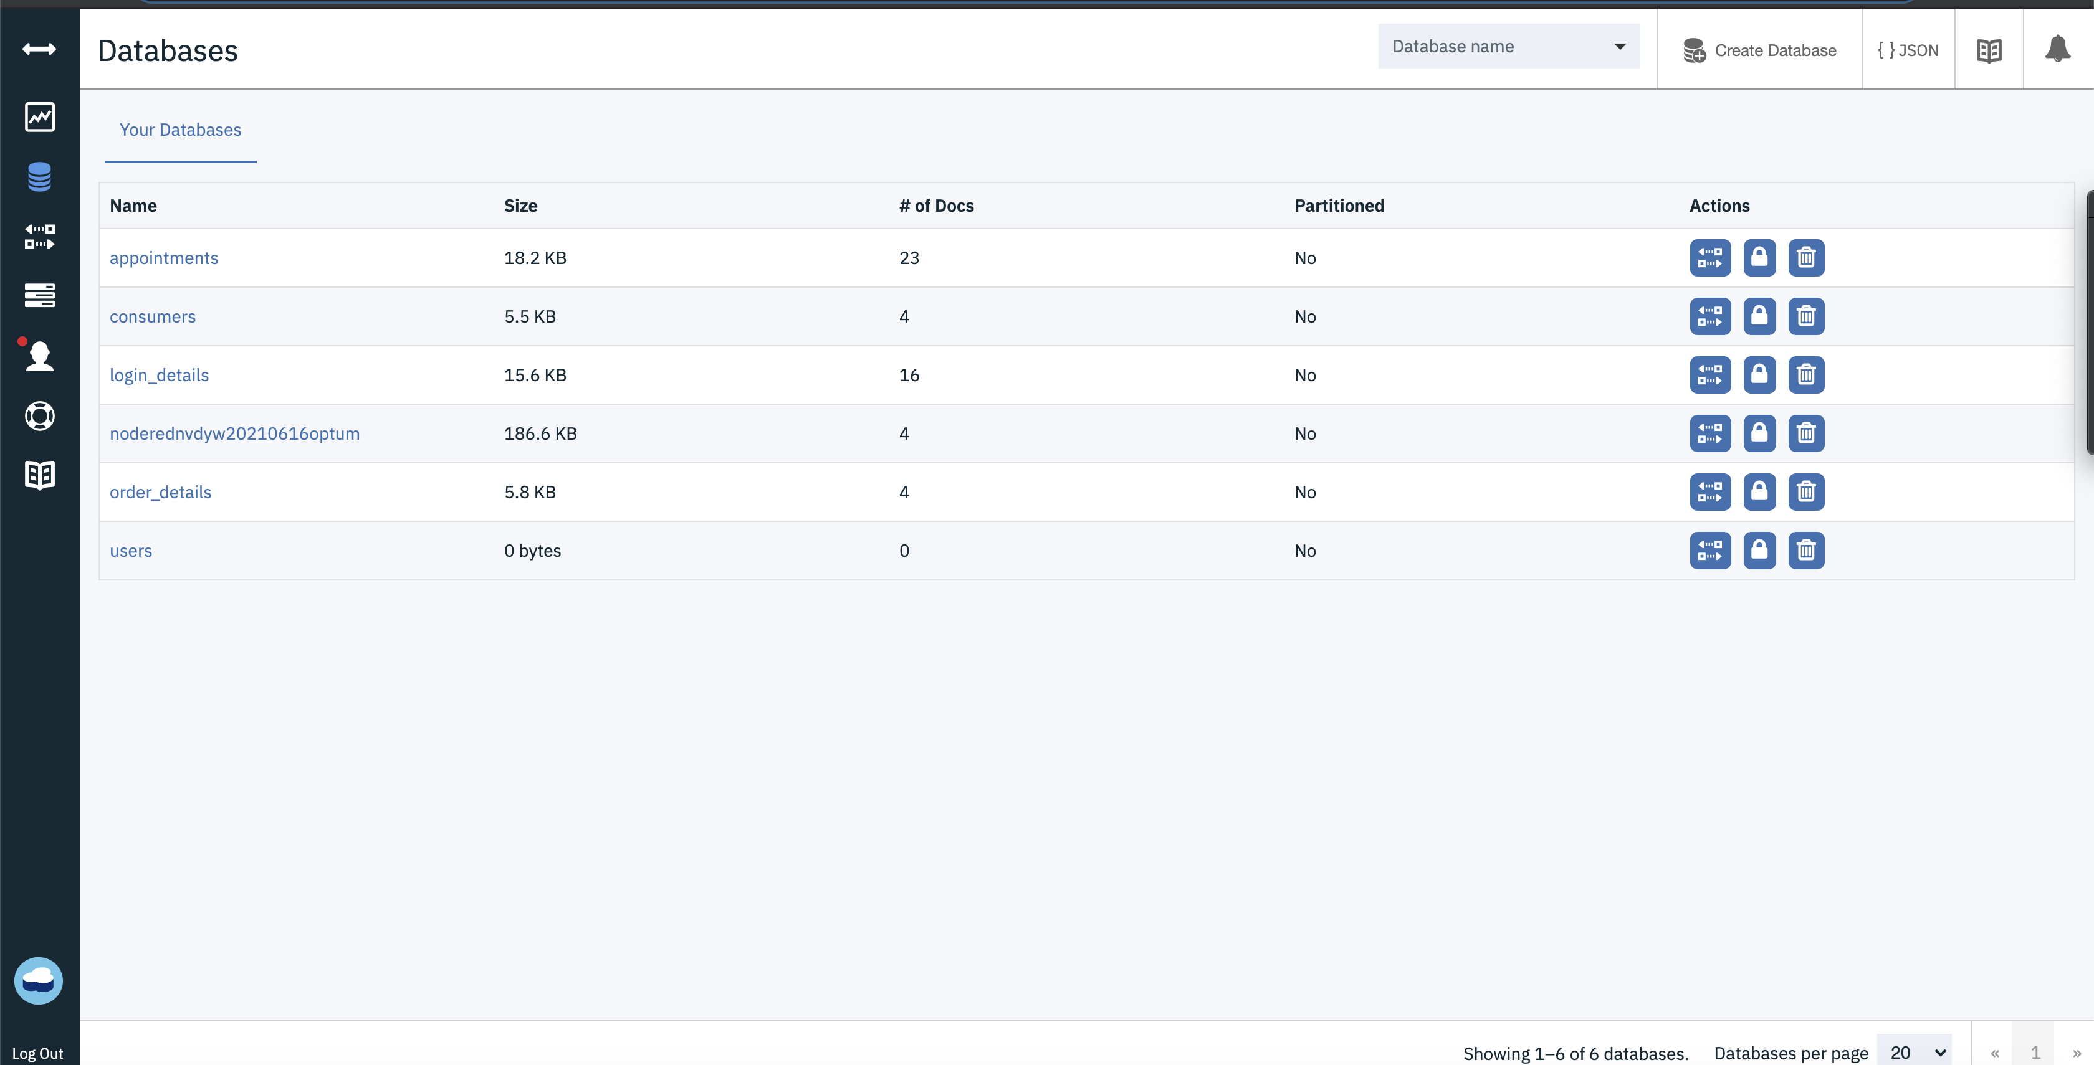

Future Updates:

* Rewards portal to be integrated with multiple offers.
* User should be able to select nearby waste collectors.
* Notify near-by waste collectors through email/phone SMS.
* Location API to be enhanced with live tracking of waste collector for better visibility to customer.
* Location API to have text to speech functionality for ease of navigation for waste collector.
* Integration of image processing to segregate based on product [Recyclable/Non-Recyclable] types
* Integration of waste collection portal with RFID to optimize data collection speed and integrity, enabling pay-as-you-throw and recycling incentive programs.